**HOW TO: CHECK IF UNIT HAS A CONTRACT CODE**

If you ever receive titles from us that are NOT endorsed and do not have a Post-it note saying “Contract Code ___ “ or “CC ___” you can check in SAM to see if it has one or not by doing the following:

* Go to VEHICLES then select TITLE
* Enter the unit number
* A screen will pop-up showing the vehicle’s title information. If there is information written under “Contract Group” and/or “Contract Code” it has a contract code and is to be endorsed from RTR to RVS even if accepted on or after 11/26/12

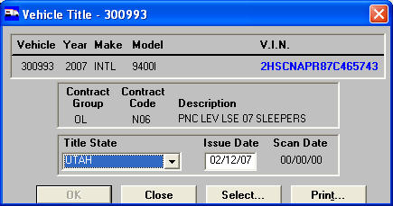

* If there is NOT information written under “Contract Group” and/or “Contract Code” and it was accepted on or after 11/26/12 it needs to be endorsed through RVP (RTR to RVP to RVS) and would need to be sent back to HQ to be endorsed if you do not have enough people on site for signatures.

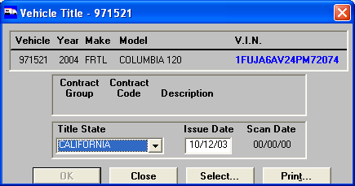

Hope that helps ☺